**Course Code: ETISR102**

**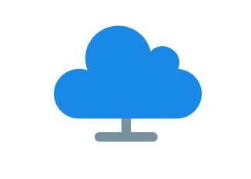Course Title:** **Independent Study and Research - II**

**CLOUD COMPUTING**

**\_\_\_\_\_\_\_\_\_\_\_\_\_\_\_\_\_\_\_\_\_\_\_\_\_\_\_\_\_\_\_\_\_\_\_\_\_\_\_\_\_\_\_\_\_\_\_**

**Name: AKSHAY VINAYAK**

**Enrollment No.: A91005216081**

**Programme: B.Tech (CSE)**

**Semester/Year: 4th Sem**

**Section:’A’**

**Email Id: akshaykaran2@gmail.com**

**Contact No.: 9874038879**

*Under the Supervisor*

*Prof. Sudip Chatterjee*

Faculty, Dept. Of CSE, Amity University Kolkata

Department of Computer Science & Engineering

AMITY School of Engineering & Technology (ASET), Kolkata

AMITY University

**Major Arterial Road, Action Area II, Rajarhat, New Town, Kolkata, West Bengal 700135**

****

|  |  |
| --- | --- |
|  | **Activities** |
| **Week One** | **Introduction ,Understanding the nature of cloud** |

|  |  |
| --- | --- |
| **Week Two** | **Grasping the fundamentals of Cloud Computing** |

|  |  |
| --- | --- |
| **Week Three** | **Cloud Characteristics and Services** |

|  |  |
| --- | --- |
| **Week Four** | **Digging deeper into cloud services** |

|  |  |
| --- | --- |
| **Week Five** | **Applications of cloud computing** |

|  |  |
| --- | --- |
| **Week Six** | **IoT - an application of cloud computing (Basics)** |

|  |  |
| --- | --- |
| **Week Seven** | **IoT- an application of cloud computing (Advanced)** |

|  |  |
| --- | --- |
| **Week Eight** | **Security and governance of cloud computing, related Algorithms** |

|  |  |
| --- | --- |
| **Week Nine** | **Conclusion / Summary** |

**CONTENTS**

**1. Introduction-------------------------------------------------------------Pg4**

* What is Cloud Computing?
* The Cloud Environment

**2. Understanding the Nature of Cloud ---------------------------------Pg5**

**3. Grasping the Fundamentals ------------------------------------------Pg6**

**4. Cloud Characteristics and Services----------------------------------Pg6**

* Cost
* Productivity
* On demand Self Service
* Security
* Rapid Elasticity or Expansion

**4.1. Cloud Computing Common Service Modals--------------Pg7**

* SaaS (Software as a Service)
* PaaS (Platform as a Service)
* IaaS (Infrastructure as a Service)

**5. Digging Deeper Into Cloud Services---------------------------------Pg10**

**5.1. Cloud computing delivery models---------------------------Pg10**

* Public
* Private
* Hybrid

**5.2. Pros and Cons of Delivery Models--------------------------Pg12**

**6. Applications of Cloud Computing** ----------------------------------------------**Pg13**

* Cloud Storage
* Marketing Cloud Platforms
* Cloud Computing in Educations
* Weather And Pollution Report In An Instant

**7. IOT- an Application of Cloud Computing (Basics) --------------Pg17**

* What Is IOT?
* Why Should We Do IOT?
* Applications

**8. IOT- an Application of Cloud Computing (Advanced) ----------Pg20**

**9. Security and governance of cloud ------------------------------------Pg25**

**9.1. Algorithm for Cloud Computing Security----------------Pg26**

* DES
* AES
* TDES
* IDEA

**10. Conclusion/ Summary--------------------------------------------------Pg28**

**11. Acknowledgment --------------------------------------------------------Pg29**

**12. References ----------------------------------------------------------------Pg29**

**13. Deliverables or Output -------------------------------------------------Pg30**

**14. Financial Statement -----------------------------------------------------Pg30**

**15. Limitations-----------------------------------------------------------------Pg30**

**16. Plagiarism Report--------------------------------------------------------Pg31**

**17. Presentation Handouts -------------------------------------------------Pg32**

1. **INTODUCTION**

Welcome to **Cloud Computing.**

**1.1) What is Cloud Computing?**

Cloud computingis more than a service sitting in some remote data centre. It’s a set of approaches that can help organizations quickly, effectively add and subtract resources in almost real time. Unlike other approaches, the cloud is as much about the business model as it is about technology Companies clearly understand that technology is at the heart of how they operate their businesses.

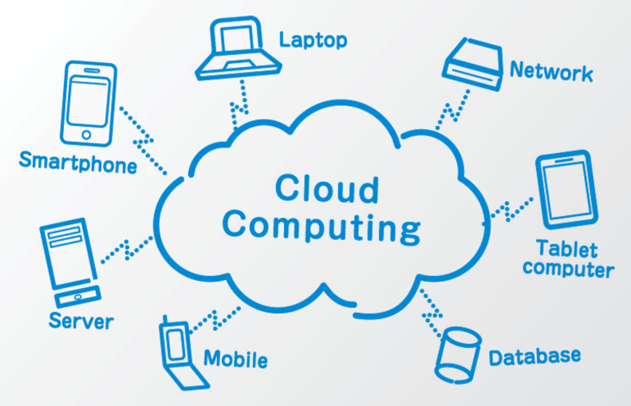

**Fig 1)** *Wide spread of Cloud Computing: Databases, Mobiles, Tablets, Network, and Server etc.*

Well; Cloud computing is a type of computing that relies on shared computing resources rather than having local servers or personal [devices](https://www.webopedia.com/TERM/D/device.html) to handle [applications](https://www.webopedia.com/TERM/A/application.html). In its most simple description, cloud computing is taking services "[CLOUD](https://www.webopedia.com/TERM/C/cloud_services.html) SERVICES" and moving them outside an organization's firewall. Applications, storage and other services are accessed via the Web. The services are delivered and used over the Internet and are paid for by the [cloud](https://www.webopedia.com/TERM/C/cloud.html) customer on an as-needed or pay-per-use business model.

**1.2) The Cloud Environment**

The cloud environment itself requires a strong foundation of best practices in software development, software architecture, and service management foundations. This strong foundation is especially important because most organizations combine public and private cloud services.

So, let’s begin our NTCC topic with a hope that this project will cover all the aspects, terms related to it and help us understand all about cloud computing.

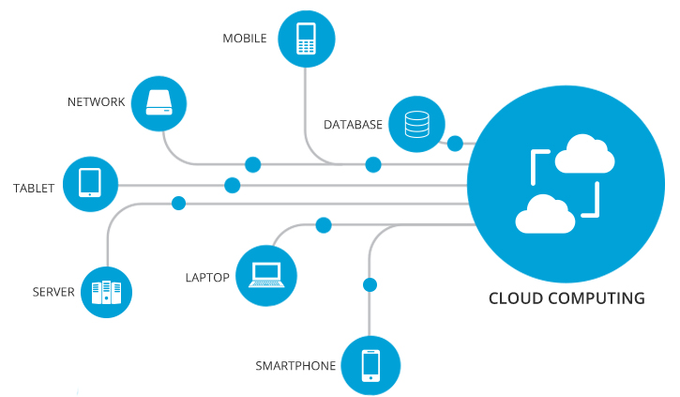

**Fig 2)** *The Cloud Environment where all the necessary devices (Gadgets) is connected t the Cloud*

1. **UNDERSTANDING THE NATURE OF CLOUD**

Cloud computing is older than it seems; cloud marked its era in early 1960’s. That time the initial concept of time-sharing became popular via RJE ([Remote Job Entry](https://en.wikipedia.org/wiki/Remote_Job_Entry)) this terminology was mostly associated with large vendors such as [IBM](https://en.wikipedia.org/wiki/IBM) (International Business Machine Corp.) and [DEC](https://en.wikipedia.org/wiki/Digital_Equipment_Corporation) (Digital Equipment Corporation). But, the term “CLOUD COMPUTING” was popularized with [Amazon.com](https://en.wikipedia.org/wiki/Amazon.com) releasing its [Elastic Compute Cloud](https://en.wikipedia.org/wiki/Amazon_Elastic_Compute_Cloud) product in 2006, references to the phrase "cloud computing" appeared as early as 1996, with the first known mention in a [Compaq](https://en.wikipedia.org/wiki/Compaq) internal doc.

After the Amazons Elastic Compute Cloud in April 2008 Google released its Google App Engine in beta that was very effective for modern day technology. The CLOUD was taking shape, after Google it was Open Nebula1 by NASA which was first open source software for developing private and

Hybrid clouds, and for the federation of clouds. Further more in 2010 Microsoft evolved by it concept of Microsoft Asure which was  a [cloud computing](https://en.wikipedia.org/wiki/Cloud_computing) service created by [Microsoft](https://en.wikipedia.org/wiki/Microsoft) for building, testing, deploying, and managing applications and services through a global network of Microsoft managed [data centres](https://en.wikipedia.org/wiki/Data_center). It provides [Software as a Service (SaaS)](https://en.wikipedia.org/wiki/Software_as_a_service), platform as a service (PaaS) and [infrastructure as a service (IaaS)](https://en.wikipedia.org/wiki/Infrastructure_as_a_service) and supports many different [programming languages](https://en.wikipedia.org/wiki/Programming_language), tools and frameworks, including both Microsoft-specific and third-party software and systems; And so on the cloud was growing rapidly according to its needs and efficiency over data that it showed in real-time.

1 Open Nebula: Open Nebula provides the **most simple but feature-rich and flexible solution** for the comprehensive management of virtualized data centres to enable private, public and hybrid IaaS clouds.

1. **GRASPING THE FUNDAMENTALS**

In a dynamic economic environment, your company’s survival may depend on your ability to focus on core business and adapt quickly. Yesterday’s profitable business model can’t be counted on to translate into future growth and profits. As your business adapts to changing government and industry regulations, evaluates new business partnerships, and anticipates competitive threats, IT needs to help the business find new ways to respond. At the same time, plans for change must often be made in the context of limited resources for finances, people, technology, and power.

Cloud computing also examines how companies are using the cloud to control IT expenditures as they prepare to move to a service-centric world.

Many players make up the world of cloud computing:

* The **vendors** providing applications and enabling technology, infrastructure, hardware, and integration.
* The **partners** of these vendors that are creating cloud services offerings and providing support services to customers.
* The **business leaders** themselves who are either using or evaluating various types of cloud computing offerings.

The goal of cloud computing is to allow users to take benefit from all of these technologies, without the need for deep knowledge about or expertise with each one of them. The cloud aims to cut costs, and helps the users focus on their core business instead of being impeded by IT obstacles. The main enabling technology for cloud computing is [virtualization](https://en.wikipedia.org/wiki/Virtualization). Virtualization software separates a physical computing device into one or more "virtual" devices, each of which can be easily used and managed to perform computing tasks.

1. **CLOUD CHARACTERISTICS AND SERVICES**

Discussing about some basic cloud characteristics that is exhibited by cloud computing according to modern day technologies also reviews and feedbacks from the real-time users.

* **COST:** First thing that come in mind is cost efficiency that how cheap it can go. Cost reductions are claimed by cloud providers. A public-cloud delivery model converts to [operational expenditure](https://en.wikipedia.org/wiki/Operational_expenditure). This purportedly lowers [barriers to entry](https://en.wikipedia.org/wiki/Barriers_to_entry), The e-FISCAL project's state-of-the-art repository contains several articles looking into cost aspects in more detail, most of them concluding that costs savings depend on the type of activities supported and the type of infrastructure available in-house.
* [**PRODUCTIVITY**](https://en.wikipedia.org/wiki/Productivity)**:** It may be increased when multiple users can work on the same data simultaneously, rather than waiting for it to be saved and emailed. Time may be saved as information does not need to be re-entered when fields are matched, nor do users need to install application software upgrades to their computer.
* **ON-DEMAND SELF-SERVICE:**  This means that cloud customers can sign up for, pay for and start using cloud resources very quickly on their own without help from a sales agent.
* [**SECURITY**](https://en.wikipedia.org/wiki/Computer_security)**:** It can improve due to centralization of data, increased security-focused resources, etc., but concerns can persist about loss of control over certain sensitive data, and the lack of security for stored [kernels](https://en.wikipedia.org/wiki/Kernel_(operating_system)). Security is often as good as or better than other traditional systems, in part because service providers are able to devote resources to solving security issues that many customers cannot afford to tackle or which they lack the technical skills to address. However, the complexity of security is greatly increased when data is distributed over a wider area or over a greater number of devices.
* **RAPID ELASTICITY OR EXPANSION:** Cloud customers can easily scale their use of resources up or down as their needs change.

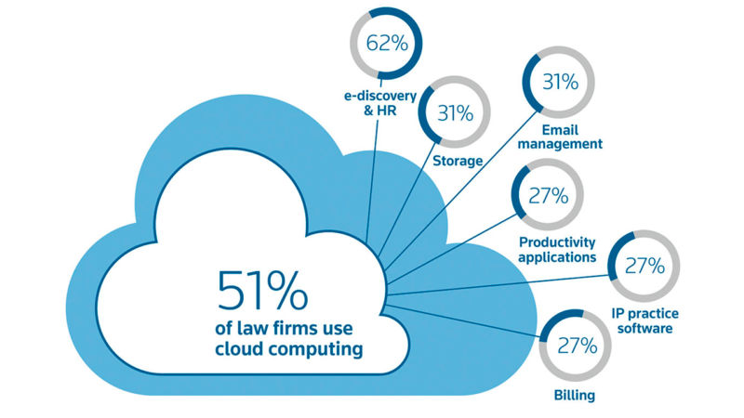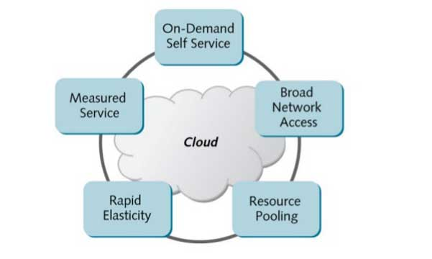There are many more characteristics but as of now these are very popular and in the mouth of all the professionals.

**Fig 3: *(****a) gives relevant cloud characteristics enlisted above (b) an example of one of the cloud characteristics in working (a working of LAW firm)*

**4.1) CLOUD COMPUTING COMMON SERVICE MODELS**

Now, let us discuss about different **cloud models** that keep a track of different resources present over cloud. Cloud services are typically deployed based on the end-user (business) requirements. The primary services include the following:

* **SOFTWARE AS A SERVICE (SAAS):**

[SaaS](https://www.webopedia.com/TERM/S/SaaS.html) is a software delivery method that provides access to software and its functions remotely as a Web-based service.  Instead of paying an upfront fee to purchase and/or license software, SaaS customers pay a recurring (often monthly or annual) fee to subscribe to the service. In general, they can access the SaaS from any Internet-connected device, any time day or night. Well-known examples of SaaS include Salesforce.com, Microsoft Office 365, Google G Suite, Dropbox, Adobe Creative Cloud and others.

* **STORAGE AS A SERVICE(SAAS) :**

This is a term used to describe a [storage](https://www.webopedia.com/TERM/S/storage.html) model where a business or organization (the client) rents or leases storage space from a third-party provider. [Data](https://www.webopedia.com/TERM/D/data.html) is transferred from the client to the service provider via the [Internet](https://www.webopedia.com/TERM/I/Internet.html) and the client would then access their stored data using software provided by the storage provider. The software is used to perform common tasks related to storage, such as data [backups](https://www.webopedia.com/TERM/B/backup.html) and data transfers.

### PLATFORM AS A SERVICE (PAAS):

### [PaaS](https://www.webopedia.com/TERM/P/PaaS.html) is a computing platform being delivered as a service. Here the platform is outsourced in place of a company or data centre purchasing and managing its own hardware and software layers. Most PaaSes are designed for developers and aim to simplify the process of creating and deploying software. For example, a Web developer might use a PaaS that includes operating system software, Web server software, a database and related Web development tools. The leading PaaS vendors include Amazon Web Services, Microsoft Azure2, IBM and Google Cloud Platform.

### 2MICROSOFT AZURE: is a [cloud computing](https://en.wikipedia.org/wiki/Cloud_computing) service created by [Microsoft](https://en.wikipedia.org/wiki/Microsoft) for building, testing, deploying, and managing applications and services through a global network of Microsoft-managed [data centres](https://en.wikipedia.org/wiki/Data_center). It provides Software as a Service (SaaS).

### INFRASTRUCTURE AS A SERVICE (IAAS):

### Computer infrastructure, such as servers, storage and networking delivered as a service.  [IaaS](https://www.webopedia.com/TERM/I/IaaS.html) is popular with enterprises that appreciate the convenience of having the cloud vendor manage their IT infrastructure. They also sometimes see cost savings as a result of paying only for the computing resources they use. The leading IaaS vendors include Amazon Web Services, Microsoft Azure, IBM and Google Cloud Platform.

### While SaaS, PaaS and IaaS are the three most common types of cloud services, cloud computing vendors sometimes also use other "as a service" labels to describe their offerings. For example, some offer database as a service (DBaaS), mobile back-end as a service (MBaaS), functions as a service (FaaS)

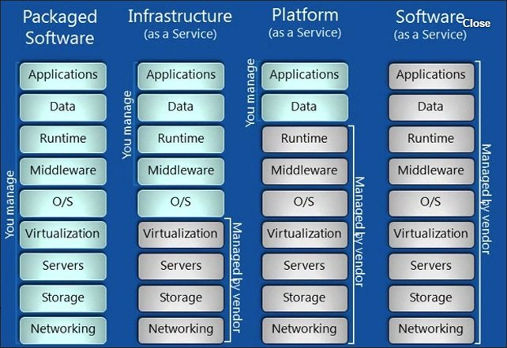

**Fig 4:** *This image gives the detailed view of all kind of services i.e. IaaS, PaaS and SaaS.*

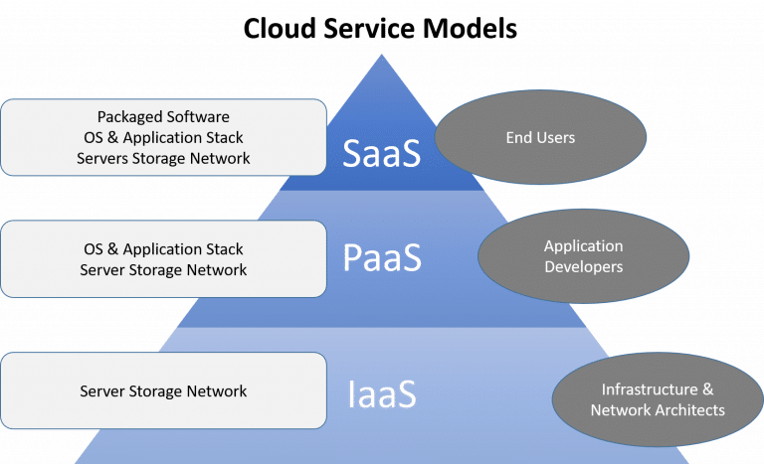

**Fig5:** *Cloud* *Services* *Models*

1. **DIGGING DEEPER INTO CLOUD SERVICES**

**5.1) CLOUD COMPUTING DELIVERY MODELS**

* **PUBLIC CLOUD:**

A public cloud is one based on the standard [cloud computing](https://searchcloudcomputing.techtarget.com/definition/cloud-computing) model, in which a service provider makes resources, such as virtual machines ([VMs](https://searchservervirtualization.techtarget.com/definition/virtual-machine)), applications or storage, available to the general public over the internet. Public cloud services may be free or offered on a pay-per-usage model.

The main benefits of using a public cloud service are:

1. it reduces the need for organizations to invest in and maintain their own on-premises IT resources;
2. it enables scalability to meet workload and user demands; and
3. There are fewer wasted resources because customers only pay for the resources they use.

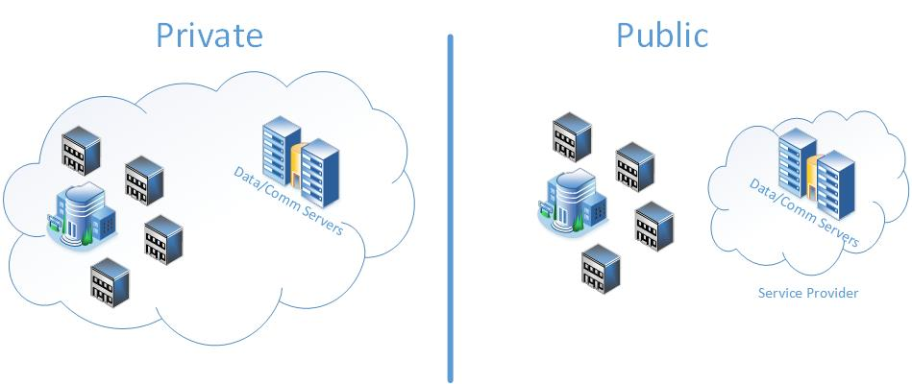

**Fig 6:** *Public Cloud that is provided by service provider and accessed by all clients*

* **PRIVATE CLOUD:**

Private cloud is a type of [cloud computing](https://searchcloudcomputing.techtarget.com/definition/cloud-computing) that delivers similar advantages to public cloud, including scalability and self-service, but through a proprietary architecture. Unlike public clouds, which deliver services to multiple organizations, a private cloud is dedicated to the needs and goals of a single organization. As a result, private cloud is best for businesses with dynamic or unpredictable computing needs that require direct control over their environments, typically to meet security, business governance or regulatory compliance requirements.



**Fig 7:** *Private cloud i.e. not accessed by all clients; restricted by the company norms.*

* **HYBRID CLOUD:**

Hybrid cloud is a cloud computing environment that uses a mix of on-premises, [private cloud](https://searchcloudcomputing.techtarget.com/definition/private-cloud) and third-party, [public cloud](https://searchcloudcomputing.techtarget.com/definition/public-cloud) services with orchestration between the two platforms. By allowing workloads to move between private and public clouds as computing needs and costs change, hybrid cloud gives businesses greater flexibility and more data deployment options. However, an enterprise has no direct control over the architecture of a public cloud, so, for a hybrid cloud deployment, it must architect its private cloud to achieve compatibility with the desired public cloud or clouds. This involves the implementation of suitable hardware within the data centre, including servers, storage, a local area network (LAN) and load balancers.

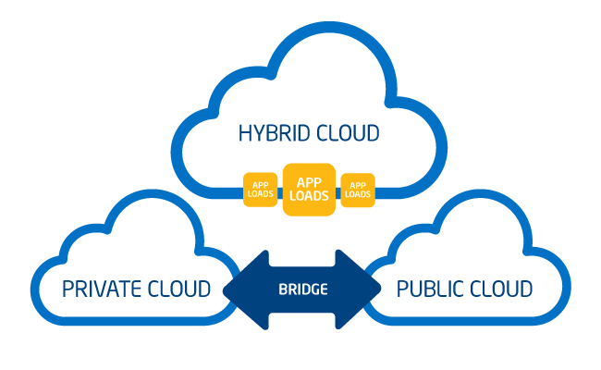

**Fig 8:** *Hybrid cloud that is linkage between private and public cloud*

**5.2) PROS AND CONS OF DELIVERY MODELS**

### Pros of private cloud:

When an organization properly architects and implements a private cloud, it can provide most of the same benefits found in public clouds, such as user self-service and scalability, as well as the ability to provision and configure virtual machines (VMs) and change or optimize computing resources on demand. An organization can also implement [chargeback](https://whatis.techtarget.com/definition/IT-chargeback-system) tools to track computing usage and ensure business units pay only for the resources or services they use. Private clouds are often deployed when public clouds are deemed inappropriate or inadequate for the needs of a business. For example, a public cloud might not provide the level of service availability or uptime that an organization needs.

### Cons of private cloud:

### However, private clouds also have some disadvantages. First, private cloud technologies, such as increased automation and user self-service, can bring some complexity into an enterprise. These technologies typically require an IT team to re-architect some of its data centre infrastructure, as well as adopt additional management tools. As a result, an organization might have to adjust or even increase its IT staff to successfully implement a private cloud.

**Pros of public cloud:**

In general, the public cloud is seen as a way for enterprises to scale IT resources on demand, without having to maintain as many infrastructure components, applications or development resources in house. The [pay-per-usage](https://searchcio.techtarget.com/definition/metered-services) pricing structure offered by most public cloud providers is also seen by some enterprises as an attractive and more flexible financial model.

**Cons of public cloud:**

However, because users typically deploy public cloud services in a [self-service model](https://searchstorage.techtarget.com/definition/self-service-cloud-computing), some companies find it difficult to accurately track cloud service usage, and potentially end up paying for more cloud resources than they actually need. Some organizations also just prefer to directly supervise and manage their own on-premises IT resources, including servers.

**Pros of hybrid cloud:**

Hybrid cloud computing enables an enterprise to deploy an on-premises private cloud to host sensitive or critical workloads, and use a third-party public cloud provider to host less-critical resources, such as test and development workloads. Hybrid cloud is also particularly valuable for dynamic or highly changeable workloads.

**Cons of hybrid cloud:**

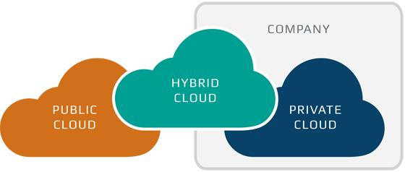Despite its benefits, hybrid cloud computing can present technical, business and management challenges. Private cloud workloads must access and interact with public cloud providers, so, as mentioned above, hybrid cloud requires API compatibility and solid network connectivity.

**Fig 9:** *Types of Cloud Public, Private and Hybrid*

1. **APPLICATIONS OF CLOUD COMPUTING**

The applications of cloud computing are practically limitless. With the right middleware, a cloud computing system could execute all the programs a normal [computer](https://computer.howstuffworks.com/pc.htm) could run. Potentially, everything from generic word processing software to customized computer programs designed for a specific company could work on a cloud computing system.

Some of real world Applications of cloud computing is as follows:

* **CLOUD STORAGES provided by companies like**

[Ex: Dropbox](http://dropbox.com/)**, Gmail, Facebook**

The number of cloud storage providers online seems to grow every day. Each competing over the amount of storage they can provide to clients.

Right now, **Dropbox** is the clear leader in streamlined cloud storage allowing users to **access files on any device through its application or website with up to 1 terabyte of free storage.** **Google’s email** service provider Gmail, on the other hand, provides unlimited storage on the cloud. Gmail has revolutionized the way we send emails and largely responsible for the [increased usage of email](http://maropost.com/blog/9-types-of-email-marketing-campaigns-you-should-be-using) worldwide. **Facebook** is a mix of the two, in that it can store an infinite amount of information, images, and videos on your profile. They can then be easily accessed on multiple devices. Facebook goes a step further with their Messenger app, which allows for profiles to exchange data.

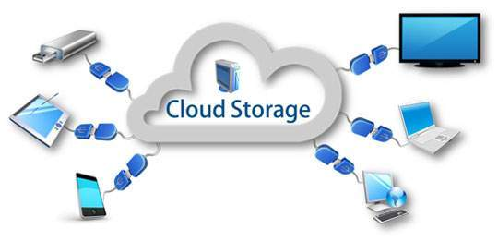

**Fig 10:** *Cloud storages are everywhere*

## ****MARKETING CLOUD PLATFORMS****

### **EX:**[Maropost marketing cloud](http://maropost.com/)****,****[Hubspot](http://hubspot.com/" \t "_blank)****,****[adobe marketing cloud](https://www.adobe.com/ca/marketing-cloud.html)

A marketing cloud is an end-to-end [digital marketing platform](http://maropost.com/products/maropost-marketing-cloud) for clients to manage contacts and target leads. 3**Maropost Marketing Cloud**combines easy-to-use marketing automation and hyper-targeting of leads. At the same time, ensuring emails actually arrive in the inbox, thanks to its advanced email deliverability capabilities. In general, marketing clouds fulfil a need for personalization. This is important in a market that demands messaging be “more human.” That’s why communicating that your brand is here to help, will make all the difference in closing.

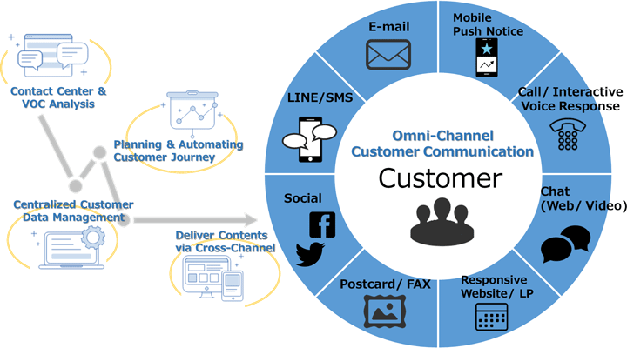

**Fig11:** *Market and Costumer communication via cloud services.*

## ****CLOUD COMPUTING IN EDUCATION****

### **Ex:**[slide rocket](http://www.sliderocket.com/)****,****[rat type](http://www.ratatype.com/)****,**Amazon**

Education is increasingly adopting advanced technology because [students already are](https://www.forbes.com/sites/nelsongranados/2017/06/20/gen-z-media-consumption-its-a-lifestyle-not-just-entertainment/#24fe6c6218c9). So, in an effort to modernize classrooms, educators have introduced e-learning software like **Slide Rocket**.

**4Slide Rocket** is a platform that students can use to **build presentations and submit them. Students can even present them through web conferencing all on the cloud.** Another tool teacher’s use is Rat type, which helps students learn to type faster and offers online typing tests to track their progress.

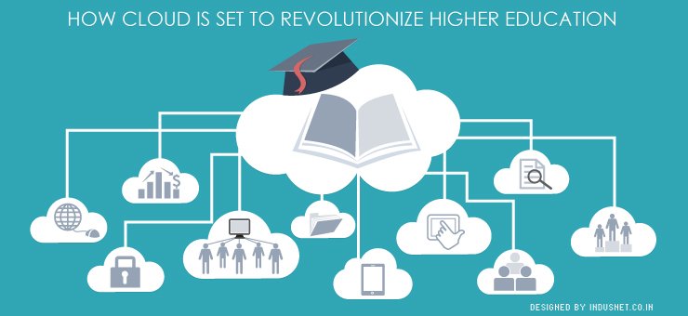

**Fig12:** *Education now days are connected via cloud.*

* **WEATHER AND POLLUTION REPORT IN AN INSTANT (REAL TIME APPLICATION)**

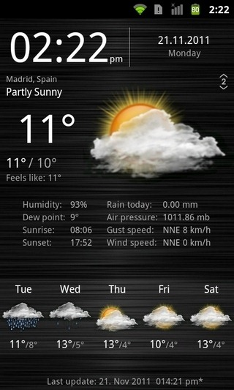Cloud basically does some statistics over this, it stores data every second and manipulate them as and when required. When any user requests for the update of weather or pollution the program or software which are designed for it gives the output and if the results or readings rise above the threshold then the indication led is lit up, so we can understand that the weather or pollution level is not up to the mark (hazardous/ danger). Google along with some others have created this kind of software that detects the pollution level and warns accordingly.

**Fig 13:** *Weather report data is huge and is stored over cloud; when demanded by users the data is calculated and processed to the users interface of search.*

**3Maropost:** Maropost Marketing Cloud provides the foundation B2C businesses need to easily create complex customer journeys, resulting in increased revenue—across email, web, mobile, and social channels. Coupled with in-depth analytics to track every part of your marketing process, Maropost Marketing Cloud is the art and science of marketing elevated.

**4Slide Rocket:** Slide Rocket was an online presentation platform that lets users create, manage, share and measure presentations. Slide Rocket is provided via a [SaaS](https://en.wikipedia.org/wiki/SaaS) model.

1. **IOT AN APPLICATION OF CLOUD COMPUTING (BASICS)**

**7.1 What is Internet of Things?**

According to Cisco “The Internet Of Things is the intelligent connectivity of physical devices driving massive games in efficiency business growth and quality of life.”

**7.2 Why should we do Internet Of Things?**

It brings efficiency, creates new economic value for the companies for the government and ultimately it improves the quality of life.

IOT is an application of cloud computing as it generates or stores data over internet and gives desired results as and when required.

**7.3 APPLICATION**

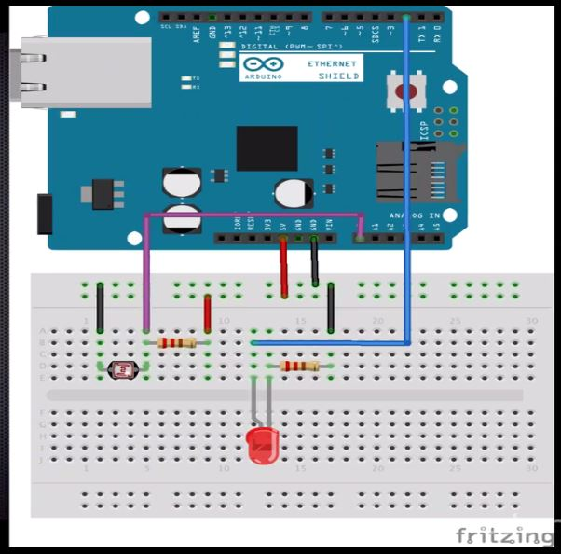Let’s start this application with simple glowing of LED light taking data from server and processing it ON and OFF.

**Aim:** Glowing LED light

**Things Required:**

1. Ardiuno uno
2. Jumper wire
3. Resistors
4. Breadboard
5. Led lights

**Fig 14:** *Application performed on Arduino Uno board (lightning of led)*

**Code Snippet**

// enter a MAC address and IP address for your controller below.

// The IP address will be dependent on your local network.

// gateway and subnet are optional:

byte mac[] = {

0x00, 0xAA, 0xBB, 0xCC, 0xDE, 0x4};

IPAddress ip(192, 168, 59, 177);

IPAddress myDns(192,168,59, 1);

IPAddress gateway(192, 168, 59, 254);

IPAddress subnet(255, 255, 225, 0);

void setup() {

pinMode(ledPin, OUTPUT);

Ethernet.begin(mac, ip, gateway, subnet);

server.begin();

Serial.begin(9600);

while(!Serial){

;

}

Serial.print("csadd;");

Serial.println(Ethernet.localIP());

}

void loop() {

EthernetClient client = server.available();

if(client) {

if(!alreadyConnected) {

client.flush();

commandString = "";

server.println("--> PLZ type the command and return..");

alreadyConnected = true;

}

while(client.available()) {

char newChar = client.read();

if(newChar==0x0D)

{

server.print("receive this command: ");

server.println(commandString);

processCommand(commandString);

} else {

Serial.println(newChar);

commandString += newChar;

}

}

}

}

void processCommand(String command)

{

server.print("processing command");

server.println(command);

if(command.indexOf("photo")> -1)

{

Serial.println("photo command received");

server.print("reading from photoresistor:");

server.println(analogRead(A0));

commandString = "";

return;

}

if (command.indexOf("ledon")> -1)

{

Serial.println("LED on command received");

digitalWrite(ledPin, HIGH);

server.println("LED was turned on");

commandString = "";

return;

}

if (command.indexOf("ledoff")> -1)

{

Serial.println("LED band command received");

digitalWrite(ledPin, LOW);

server.println("LED was band");

commandString = "";

return;

}

commandString ="";

instructions();

}

void instructions()

{

server.println(" Not Understood Cmmand ");

server.println("Use only one value: ");

server.println("\*photo , read by photo resistor");

server.println("\* ledon, LED is ON");

server.println("\* ledoff, LED OFF");

}

1. **IOT AN 5APPLICATION OF CLOUD COMPUTING (ADVANCED)**

Under this sub heading application of real time use of Cloud Computing is shown by running of Pollution Check.

**DESCRIPTION:** This application runs on the server and it generates data every 5 sec. The Apparatus checks for Temperature Humidity, Smoke detection, Gas detection (nearly components of pollution). When the working model is exposed to Smoke or Gas the embedded sensors detect them and when it crosses the threshold it gives a warning by glowing of led. The Model also shows the temperature rise and humidity so as to make a move before some hazard can happen.

This is a very good model that can be implemented in various places like Auditoriums, Theatres, Class Labs, and House etc. and lives of many people can be saved. This is how we detect the pollution and some action can be taken for rescue purpose.

**5Application (Pollution check):** This application model is designed such a way that it can be used in market for several purposes protections and it will be handy to all customers. At least lives of people can be saved from hazardious gases or smoke from now a days pollution levels.

**Aim:** Pollution check and alerting people

**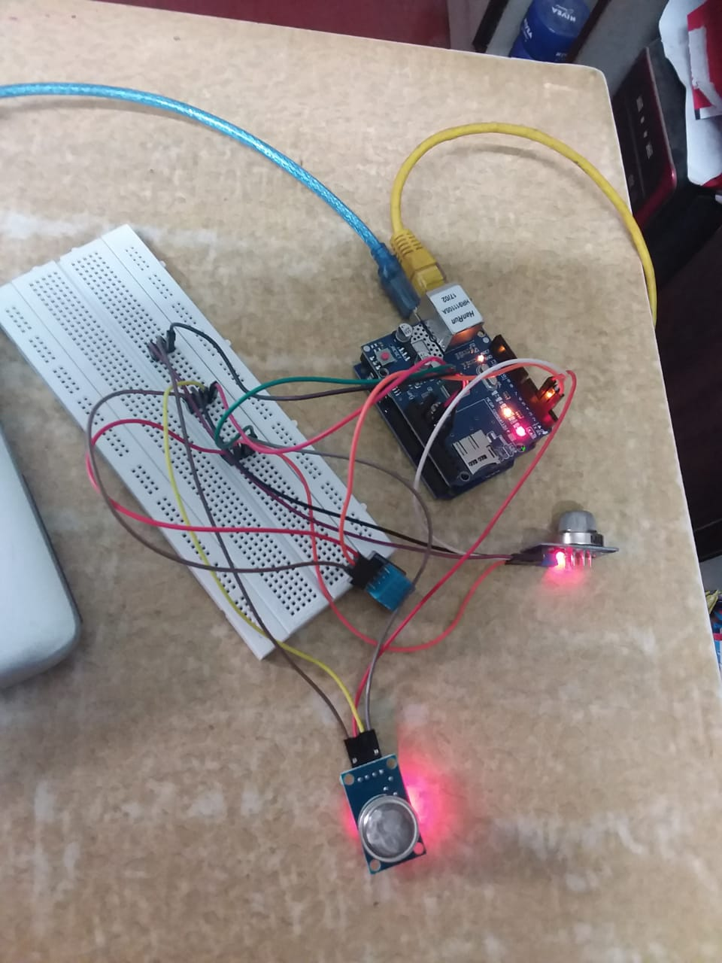Things Required:**

1. Ardiuno uno
2. Jumper wire
3. Resistors
4. Breadboard
5. DHT11
6. MQ2
7. MQ9
8. Ethernet shield
9. LED

**Fi**

**Fig 15:** *Pollution check made on Arduino Uno board that detects Gas, Smoke, variable Temperature and Humidity according to that environment and alerts accordingly*

**Code Snippet**

#define gasPin2 4 // MQ9(gas)

#define redLed 5

// Enter a MAC address and IP address for your controller below.

// The IP address will be dependent on your local network:

byte mac[] = {

0xDE, 0xAD, 0xBE, 0xEF, 0xFE, 0xED };

IPAddress ip(192, 168, 1, 177);

// Your threshold value

int sensorThresgasPin1=330;

int sensorThresgasPin2=400;

// Initialize the Ethernet server library

// with the IP address and port you want to use

// (port 80 is default for HTTP):

EthernetServer server(80);

#define DHTTYPE DHT11

DHT dht(DHTPIN, DHTTYPE);

void setup() {

// Open serial communications and wait for port to open:

Serial.begin(9600);

dht.begin();

// start the Ethernet connection and the server:

Ethernet.begin(mac, ip);

server.begin();

Serial.print("server is at ");

Serial.println(Ethernet.localIP());

}

void loop() {

// listen for incoming clients

EthernetClient client = server.available();

if (client) {

Serial.println("new client");

// an http request ends with a blank line

// output the value of each analog input pin

int sensorReading = analogRead(0);

client.print("analog input ");

client.print(0);

client.print(" is ");

client.print(sensorReading);

client.println("<br />");

float h =dht.readHumidity();

float t =dht.readTemperature();

if (isnan(t)|| isnan(h)){

Serial.println("Failed to read from DHT");

}else{

client.print("humidity: ");

client.println(h);

client.print("Temperature: ");

client.println(t);

client.println("<br />");

client.println("<br />");

client.println("<=======================================>");

}

client.print("SMOKE SENSOR: ");

client.println(analogRead(gasPin1));

if (analogSensor > sensorThresgasPin2)

{

digitalWrite(redLed, HIGH);

}

else

{

digitalWrite(redLed, LOW);

}

delay(1000);

client.println("<br />");

client.println("<br />");

client.println("<=======================================>");

client.println("<br />");

client.print("GAS SENSOR: ");

client.println(analogRead(gasPin2));

if (analogSensor > sensorThresgasPin2)

{

digitalWrite(redLed, HIGH);

}

else

{

digitalWrite(redLed, LOW);

}

delay(1000);

client.println("<br />");

client.println("<br />");

client.println("<=======================================>");

client.println("</html>");

break;

}

if (c == '\n') {

// you're starting a new line

currentLineIsBlank = true;

}

else if (c != '\r') {

// you've gotten a character on the current line

currentLineIsBlank = false;

}

}

}

// give the web browser time to receive the data

delay(1);

// close the connection:

client.stop();

Serial.println("client disonnected");

}

}

1. **SECURITY AND GOVERNANCE OF CLOUD**

Many companies contemplating the addition of the cloud into their IT strategy are concerned about three key issues: Security, Accountability, and Reliability. Security is top on the list of any IT manager who’s thinking about the cloud. Whether you’re looking at creating a private  
cloud, leveraging a public cloud, or implementing a hybrid environment, you must have a security strategy.

Many of the same security risks that companies face when dealing with their own computer systems are found in the cloud, but there are some important twists. With the cloud, you no longer have well-defined boundaries regarding what’s internal and what’s external to your systems. You must assess whether holes or vulnerabilities exist across servers, networks, infrastructure components, and endpoints and then continuously monitor them.

According to the Cloud Security Alliance (CSA), an organization dedicated to ensuring security best practices in the cloud; significant areas of operational risk in the cloud include the following:

* **Physical security:** Covers security of IT equipment, network assets, and telecommunications infrastructure.
* **Human resource security:** Deals with the people side of the equation ensuring background checks, confidentiality, and segregation of duties (for example, those who develop applications don’t operate them).
* **Business continuity:** Ensures that the provider meets its service level agreement for operation with you.
* **Disaster recovery:** Ensures that your assets (your data and applications) are protected if, for example, you’re using a public Infrastructure as a Service (IaaS) to run an application, find out what happens if there’s some sort of disaster (natural or otherwise).
* **Incident handling changes in a cloud:** Working with your service provider to control at least part of the infrastructure.

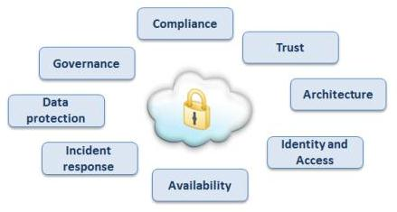

**Fig 16:** *Cloud security consists of these kinds of factors.*

**9.1) ALGORITHMS FOR CLOUD COMPUTING SECURITY**

* **Data Encryption Standard (DES):**

DES is very commonly used symmetric key algorithm. It was developed by IBM in 1974, but now a day’s many methods are found that had proven this algorithm unsecured. In DES algorithms block cipher is of 64 bits and key used is of 56 bits out of 64 bits of key is used rest of 8 bits are padded. In block cipher we encrypt block of data which consist of plain text by combination of confusion and diffusion to make cipher block then this cipher block has to pass 16 rounds, before passing through these 16 rounds the 64 bits of data is divided into 32 bits. After dividing the data into 32 bits, F-function (Feistel function) is applied. F-function consists of substitution, permutation, key mixing. The output of function is combined with other half of the data using XOR gate alternate crossing of data is done; then crossing of data is done.

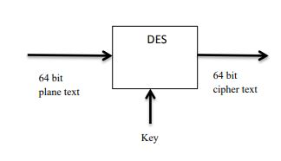

**Fig 17:** *Data Encryption Standard (DES)*

* **Advance Encryption Algorithm (AES):**

Advance Encryption algorithm AES is also known as Rijndael. AES is announced as U.S FIPS by NIST in 2001. In AES, different size of key is used i.e. 128, 192 or 256 bits, depends on how many cycle it uses. For 10 cycles 128-bit key, 12 cycles 192 bit key and for 14 cycles 256 bit key is used. All rounds of AES are similar except the last one. AES works on 4x4 matrixes. AES consists of key expansion, initial and final round. Initial round consist of Add Round Key, Sub Bytes, Shift Rows, Mix Columns, Add Round Key and final round also consists of similar function as initial round except mix columns. AES works fast on both software and hardware.

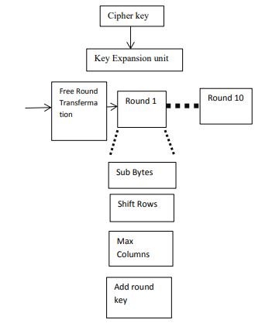

**Fig 18:** *Advance Encryption Algorithm (AES)*

* **Triple- DES (TDES)**

TDES is enhanced version of DES in TDES the key size is increased to increase i.e. 168 bits the security of data. In TDES only size of key is increased rest of the working is similar to DES. In TDES three different keys are applied on cipher block.

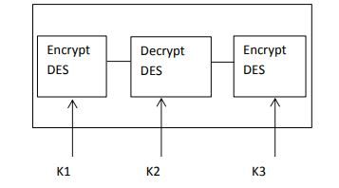

**Fig 19:** *Triple Data Encryption System(TDES)*

* **IDEA**

International Data Encryption Algorithm was proposed by James Massey and Xuejia Lai in 1991.It is considered as best symmetric key algorithm. It accepts 64 bits plain text and key size is 128 bits. IDEA consists of 8.5 rounds. All rounds are similar except the one. In IDEA the 64 bits of data is divided into 4 blocks each having size 16 bits. Now basic operations modular, addition, multiplication, and bitwise exclusive OR (XOR) are applied on sub blocks.

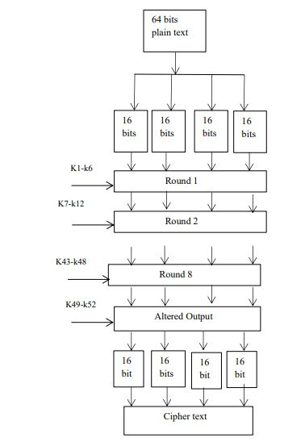

**Fig 20:** *International Data Encryption Algorithm (IDEA)*

1. **CONCLUSION/ SUMMARY**

When you deploy applications on your own premises, you can control your resources and you hopefully know who’s responsible for maintaining the integrity of the overall environment. When you move some of your computing to a cloud environment, the way you think about managing changes dramatically. You need to find the right balance between the oversight you must provide to internal customers and the way you monitor your cloud provider. We expect that many companies will have a combination of on-premise data centres combined with some cloud-based services. Therefore, you have to juggle a variety of management approaches. When you begin to leverage cloud services, you must have a clear understanding of how that resource will be managed by that provider. The company you have partnered with has to manage the underlying infrastructure that you’re using (along with its multitude of other customers). This includes the physical servers, networks, and storage, as well as any virtual servers.

1. **ACKNOWLEDGMENT**

Apart from the efforts of me, the success of any project depends largely on the encouragement and guidelines of many others. I take this opportunity to express my gratitude to the people who have been instrumental in the successful completion of this project. I would like to show my greatest appreciation to my mentor **Prof. SUDIP CHATERJEE**. I can’t say thank you enough for his tremendous support and help. I feel motivated and encouraged every time I attend his meeting. Without his encouragement and guidance this project would not have materialized. The guidance and support received from all the members who contributed and who are contributing to this project, was vital for the success of the project. I am grateful for their constant support and help.

1. **REFERENCES**

**Conference Paper:** [Advanced Computing & Communication Technologies (ACCT), 2012 Second International Conference on](https://ieeexplore.ieee.org/xpl/mostRecentIssue.jsp?punumber=6167332) Cloud Computing.

**Book:** Cloud Computing for Dummies by Dr. Fern Helper

**Web Site:** [https://en.wikipedia.org/wiki/Cloud computing](https://en.wikipedia.org/wiki/Cloud%20computing) and [www.arduino.cc](http://www.arduino.cc)

1. **DELIVERABLES OR/AND OUTPUT**

|  |  |  |  |  |
| --- | --- | --- | --- | --- |
| **Output / Deliverables are distributable** | **Yes** |  | **No** |  |

**Description:**

CD contents:

* + Document ( Report On Cloud Computing)
  + Synopsis
  + Ppt.
  + Images
  + Video (Basic, Advanced)
    - Basic: Glowing of LED via Arduino on server (Ethernet)
    - Advanced: Pollution Check

1. **FINANTIAL STATEMENT**

|  |  |
| --- | --- |
| **COMPONENTS** | **PRICE(** ₹**)** |
| Arduino Uno | 400 |
| Bread board | 70 |
| Ethernet shield | 550 |
| MQ2 Sensor | 150 |
| MQ9 Sensor | 180 |
| Jumper wire | 60 |
| resistors | 5 |
| LED | 5 |
| DHT11 | 140 |

1. **LIMITATIONS**

Basically the main project is all about the pollution sensing which senses the different kind of pollution that is gas, smoke and various other things. This was a small scale project done. On a larger scale project it can have many more sensors like particulate sensors and ozone gas, fire and NO2 sensor.

This project on a larger scale can have 5 to 6 Arduino(s) connected to the same server via Wi-Fi and the data readings taken at every interval of time. If any large change is sensed then it will send you an e-mail or will notify you. The data collected on the large scale can be analyzed as well and to save the environment by knowing the rising change in the environment.

1. **PLAGIARISM REPORT**

**Url**: **http://plagiarisma.net/**

**